23MAT206

OPTIMIZATION TECHNIQUES

LAB MANUAL



**Department of Mathematics**

**Amrita School of Engineering**

**Amrita Vishwa Vidyapeetham**

**Amaravati Campus**

|  |  |
| --- | --- |
| **Submitted by** | |
| Name | Astha Kiran |
| Roll No | AV.SC.U4CSE24010 |
| Year/Sem/Section | 2nd Year/3rd Sem/CSE-A |
| Date of Submission | 24/10/2025 |
| **Submitted to** | |
| Name | Dr. Rashmi |
| Department | Mathematics |
| Designation | Asst. Professor |

|  |  |  |  |
| --- | --- | --- | --- |
| S.no. | Title | Page no. | Remarks |
| 1. | To find gradient and hessian of the given funcn f=5x+8y+xy-x2-2y2 at[1,2] | 4 |  |
| 2. | To find gradient and hessian of the given funcn f=x1x2x3 at [1,2,3] | 4 |  |
| 3. | To find gradient nd hessian of the given funcn f=(1/3)x13-4x1+(1/3)x23-16e(x2) at[1,0] | 5 |  |
| 4. | To check the given matrix is definite or indefinite. | 6 |  |
| 5. | Find gradient and hessian of the given funcn f at[1,1] | 7 |  |
| 6. | Consider the following function.  a. Find the gradient and Hessian of f at the point [1,1].  b. Find the directional derivative of f at [1,1] with respect to a unit vector in the direction of maximal rate of increase.  c. Find a point that satisfies the FONC (interior case) for f. Does this point satisfy the SONC (for a minimizer)? | 8 |  |
| 7. | Consider the following function:  a. In what direction does the function f decrease most rapidly at the point x(0) = [2,1] ?  b. What is the rate of increase of f at the point x(0) in the direction of maximum decrease of f?  c. Find the rate of increase of f at the point x(0) in the direction d = [3,4] . | 9 |  |
| 8. | Consider the following function f :    a. Find the directional derivative of f at [0,1] in the direction [1,0] .  b. Find all points that satisfy the first-order necessary condition for f. Does f have a minimizer? If it does, then find all minimizer(s); otherwise, explain why it does not. | 10 |  |
| 9. | Given f=x12+x22 find critical points and check concavity. | 11 |  |
| 10. | Given f=(x+1)2+3 find critical points and check whether it is local maximizer or minimizer. | 12 |  |
| 11. | Use Golden Section Search to minimize  f(x) = x4 - 14x3 + 60x2 - 70x at interval [0,2] with accuracy 0.3. | 13 |  |

**INDEX**

**INDEX**

|  |  |  |  |
| --- | --- | --- | --- |
| S.no. | Title | Page no. | Remarks |
| 12. | Perform two iterations leading to the minimization of f(x1,x2)=x1+(1/2)x2+(1/2)x12+x22+3 using the steepest descent method with the starting point x(0)= 0. Also determine an optimal solution analytically. | 14 |  |
| 13. | Use the method of steepest descent to find the minimizer of | 15 |  |
| 14. | Let Then, starting from an arbitrary initial point x(0). | 16 |  |
| 15. | Let the function f be given by  Find the minimizer of f using a fixed-step-size gradient algorithm where α is a fixed step size. | 17 |  |
| 16. | Suppose that we have a unimodal function over the interval [5, 8]. Give an example of a desired final uncertainty range where the golden section method requires at least four iterations, whereas the Fibonacci method requires only three. You may choose an arbitrarily small value of ε for the Fibonacci method. | 18 |  |
| 17. | Suppose that we wish to use the golden section search method to find the value of x that minimizes in the interval [0,2] of x within a range of 0.3. | 19 |  |
| 18. | Use the golden section search method to find the value of x that minimizes in the interval [1,2] of x within a range of 0.23. | 20 |  |
| 19. | Use the Fibonacci method to find the value of x that minimizes in the interval [1,2] of x within a range of 0.23. | 21 |  |
| 20. | Write a matlab code to find minimizer of a given function using Newton’s Method. | 22 |  |
| 21. | Write a matlab code to find root of a given function using Newton’s Rapson Method. | 23 |  |
| 22. | Write a matlab code to find minimizer of a given function using Newton’s Method for 2 variable | 24 |  |

1. **To find gradient and hessian of the given function f=5x+8y+xy-x2-2y2 at[1,2]**

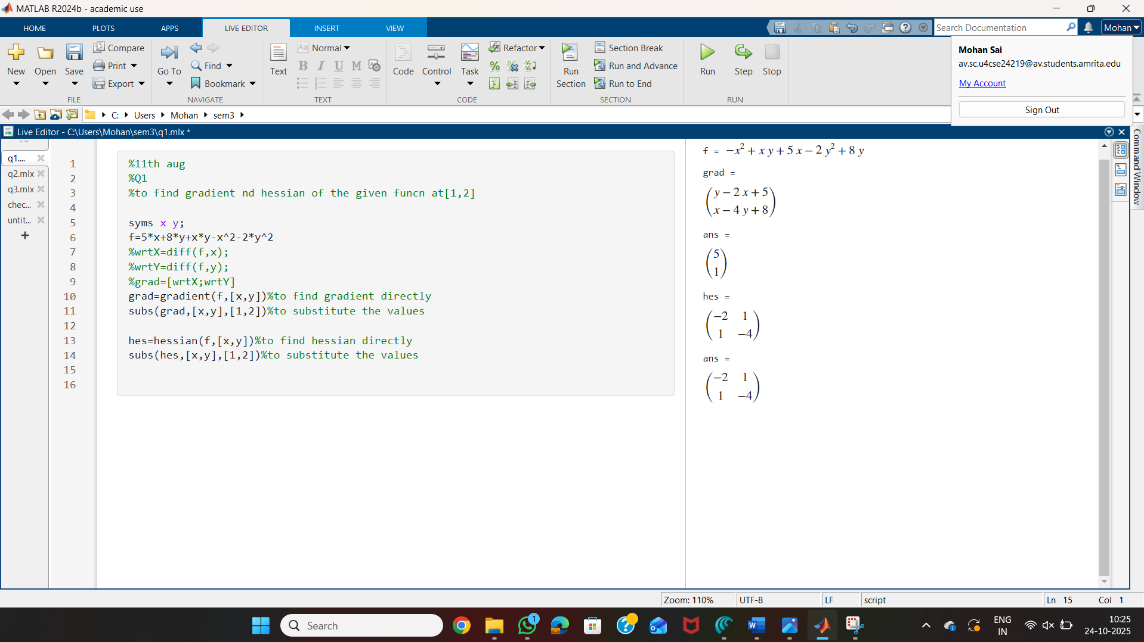

1. **To find gradient and hessian of the given funcn f=x1x2x3 at [1,2,3]**

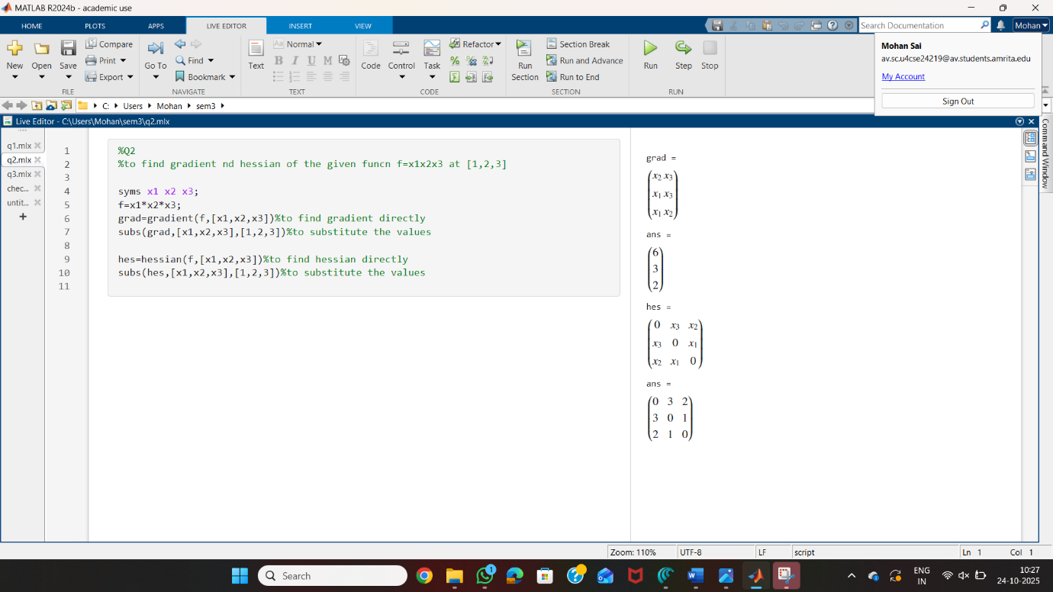

1. **To find gradient nd hessian of the given funcn f=(1/3)x13-4x1+(1/3)x23-16e(x2) at[1,0].**

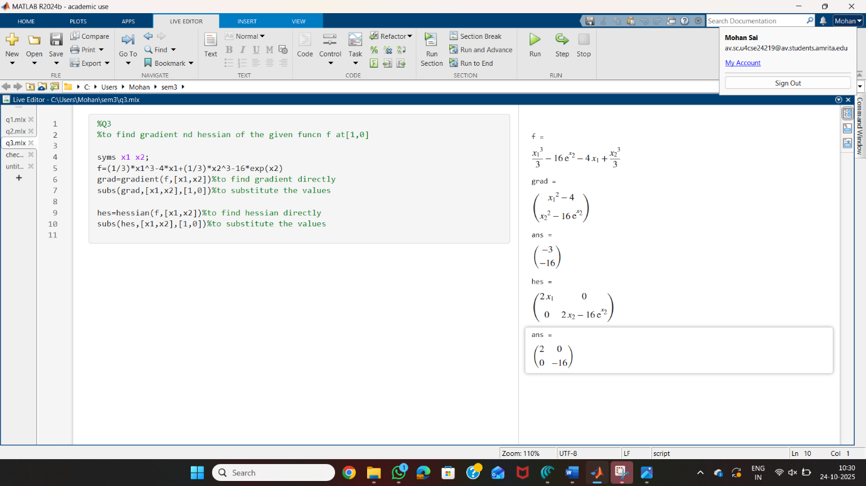

1. **To check the given matrix is definite or indefinite.**

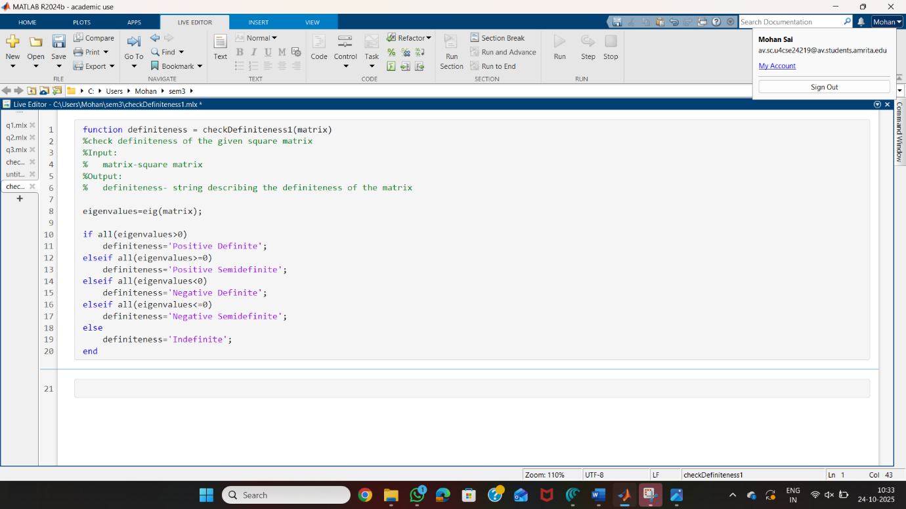

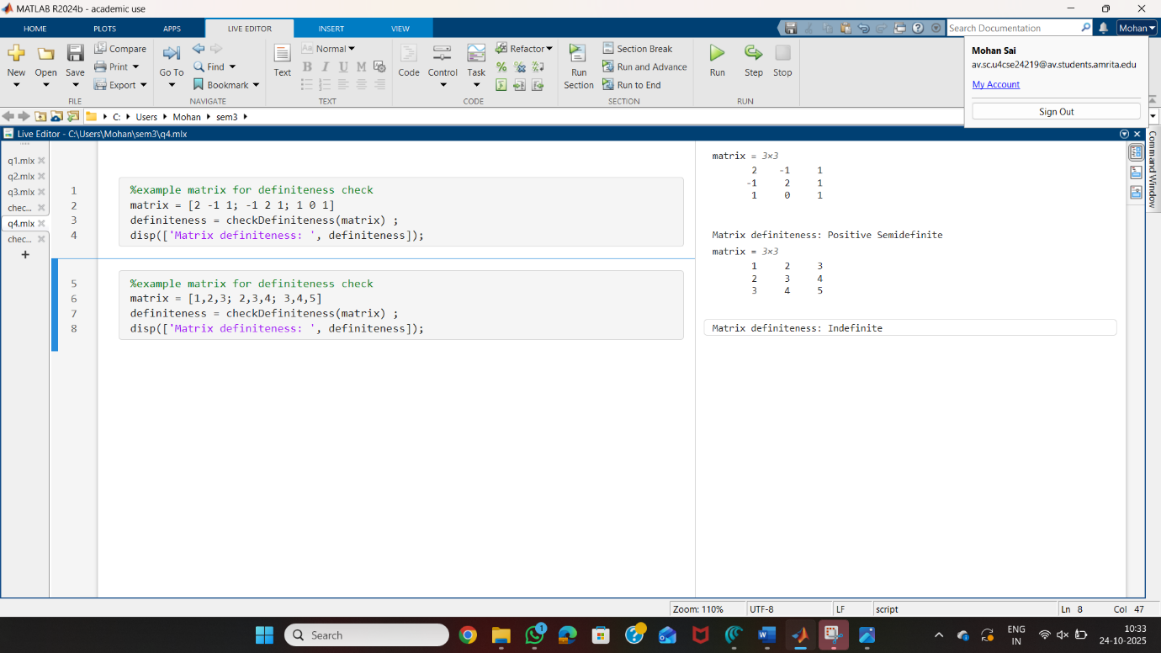

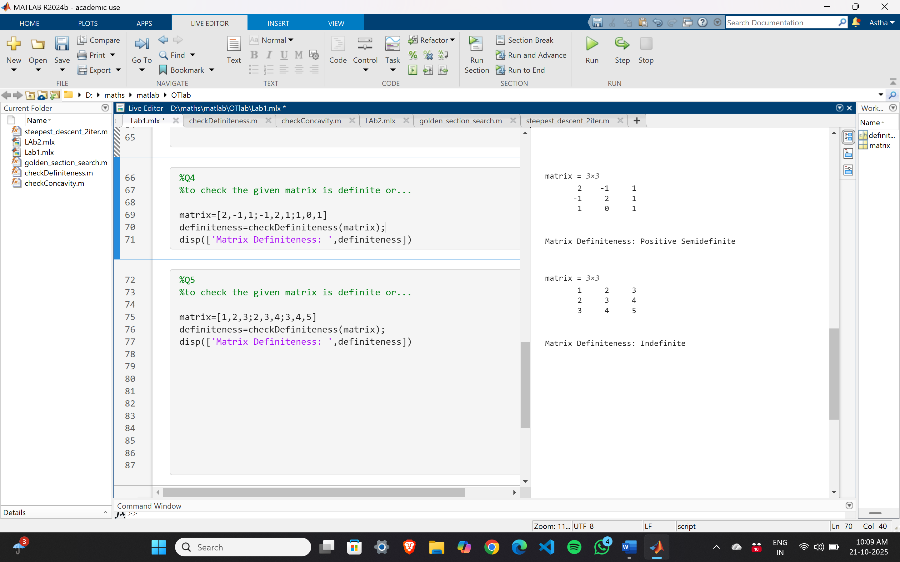

1. **Find gradient and hessian of the given funcn f at[1,1]** 

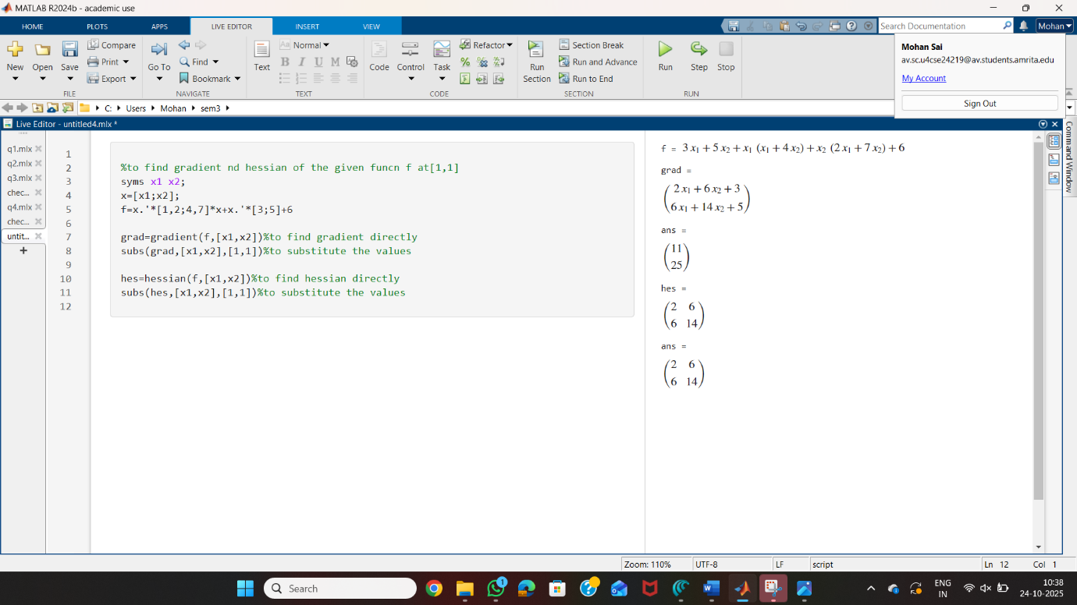

1. 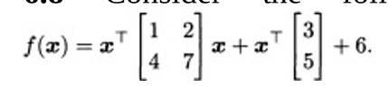**Consider the following function.**
2. **Find the gradient and Hessian of f at the point [1,1] .**
3. **b. Find the directional derivative of f at [1,1] with respect to a unit vector in the direction of maximal rate of increase.**
4. **c. Find a point that satisfies the FONC (interior case) for f. Does this point satisfy the SONC (for a minimizer)?**

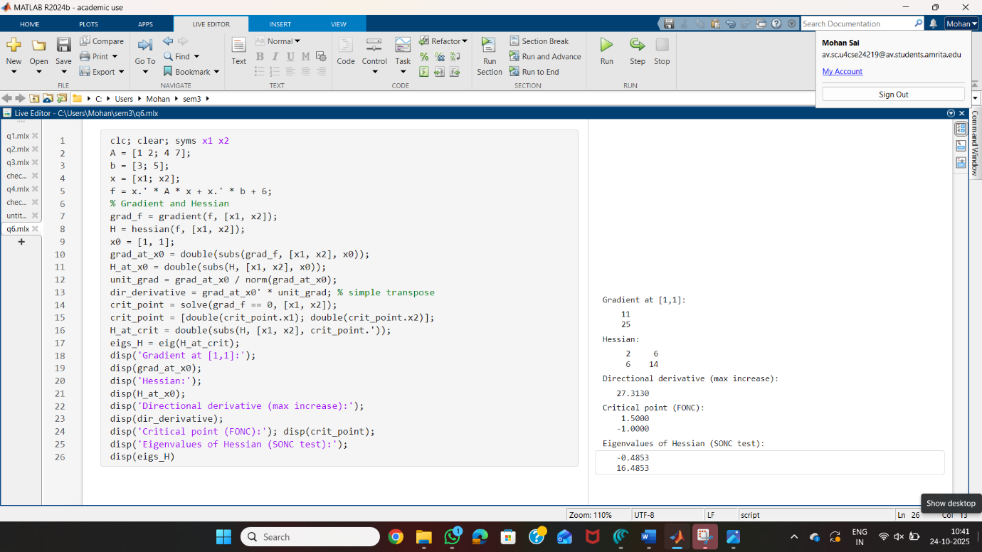

1. 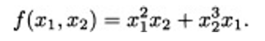**Consider the following function:**

**a. In what direction does the function f decrease most rapidly at the point x(0) = [2,1] ?**

**b. What is the rate of increase of f at the point x(0) in the direction of maximum decrease of f?**

**c. Find the rate of increase of f at the point x(0) in the direction d = [3,4] .**

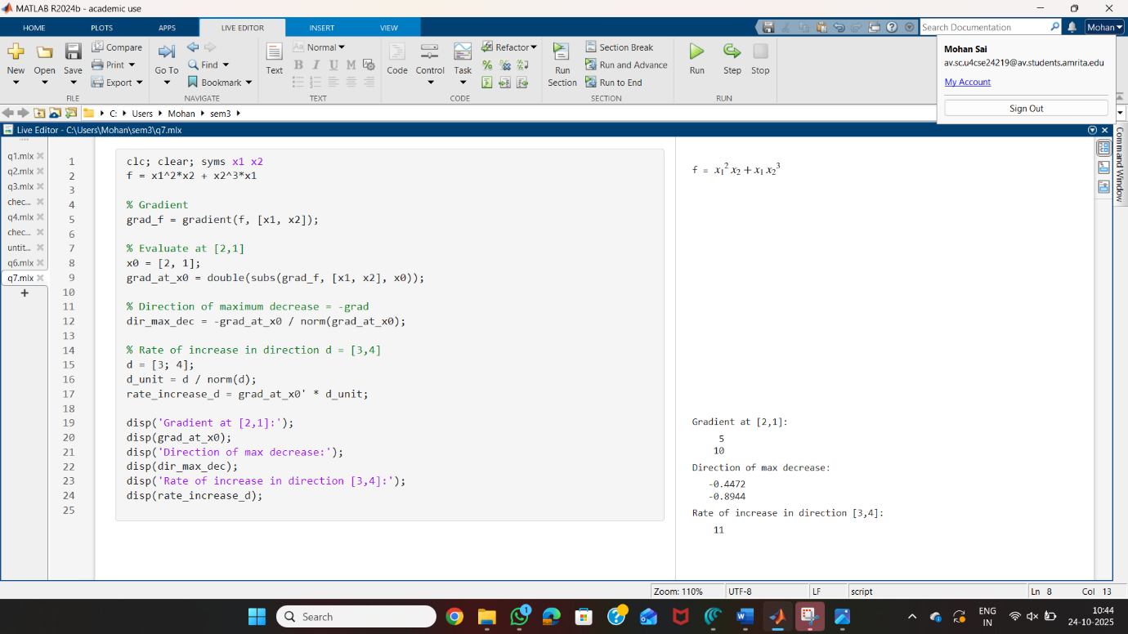

1. 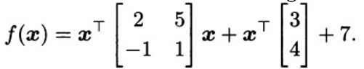**Consider the following function f :**

**a. Find the directional derivative of f at [0,1] in the direction [1,0] .**

**b. Find all points that satisfy the first-order necessary condition for f. Does f have a minimizer? If it does, then find all minimizer(s); otherwise, explain why it does not.**

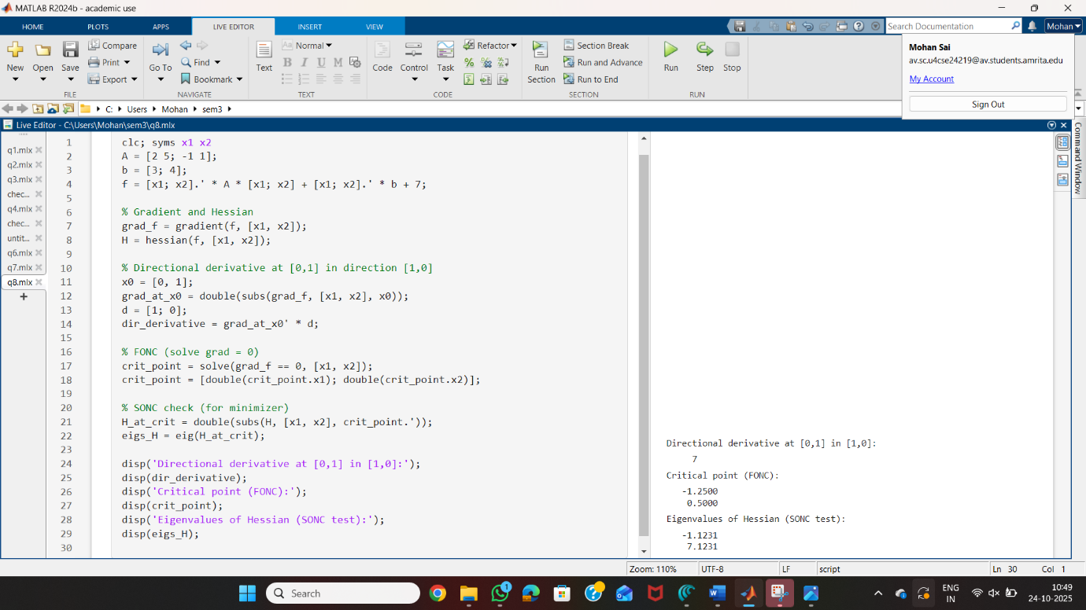

1. **Given f=x12+x22 find critical points and check concavity.**

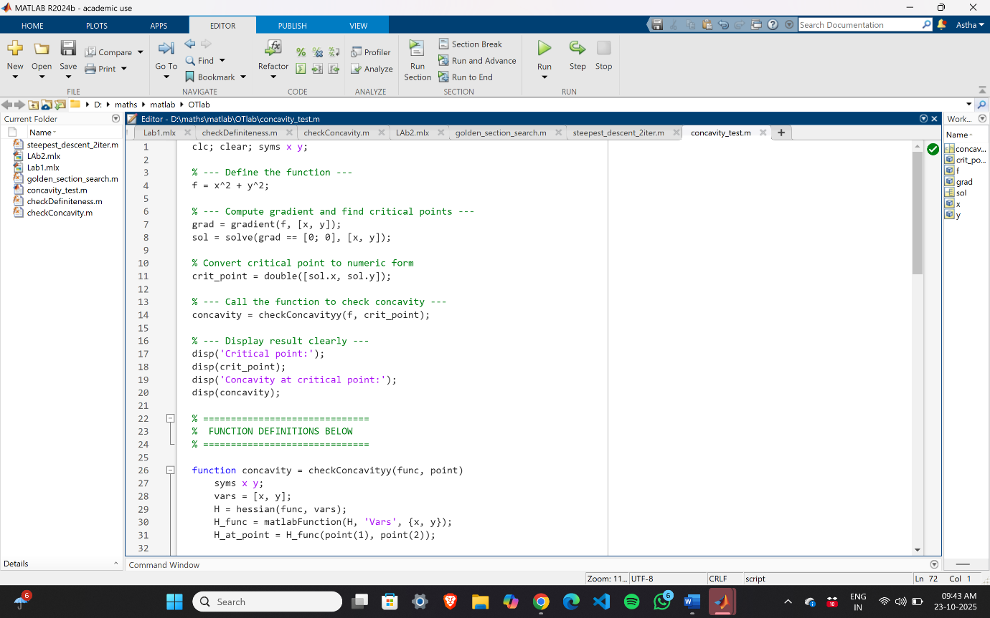

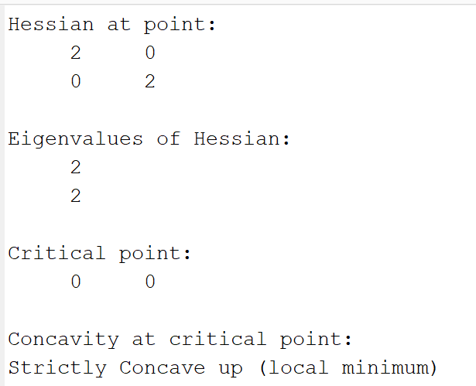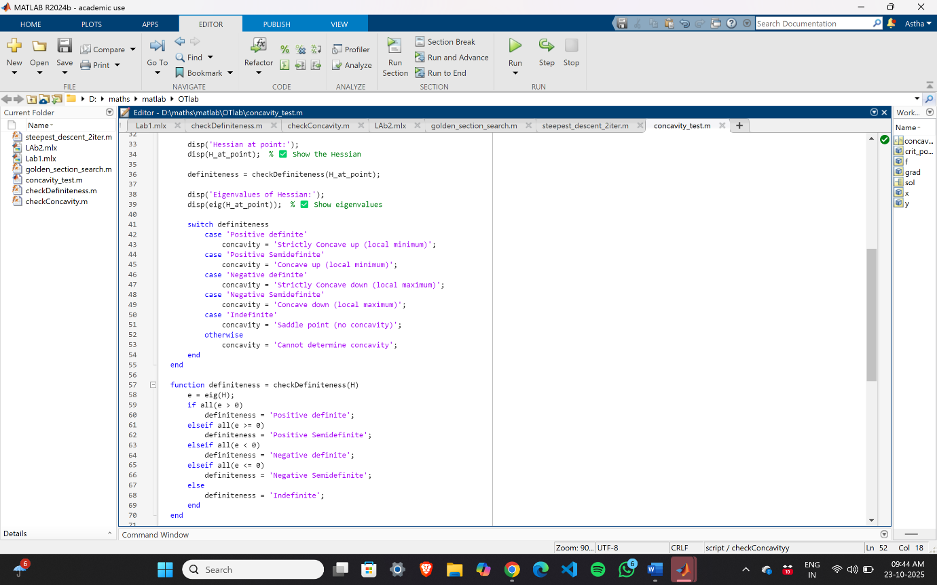

1. **Given f=(x+1)2+3 find critical points and check whether it is local maximizer or minimizer.**

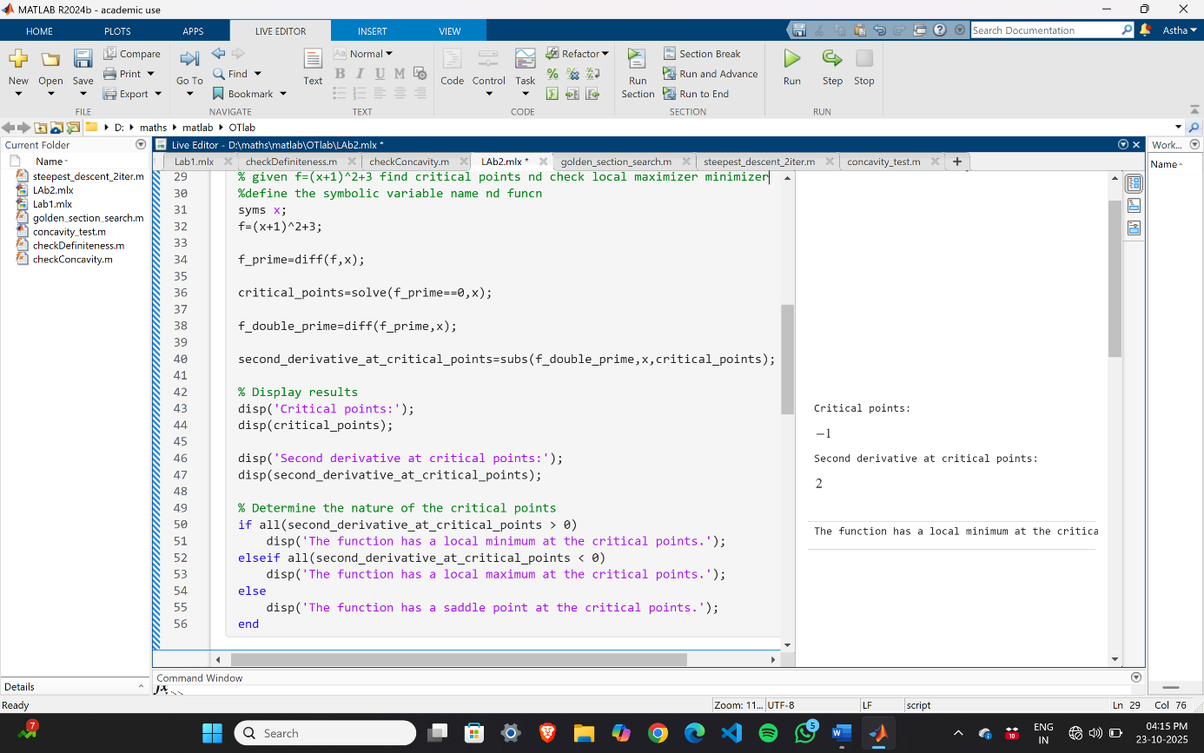

1. **Use Golden Section Search to minimize f(x) = x^4 - 14x^3 + 60x^2 - 70x at interval [0,2] with accuracy of 0.3.**

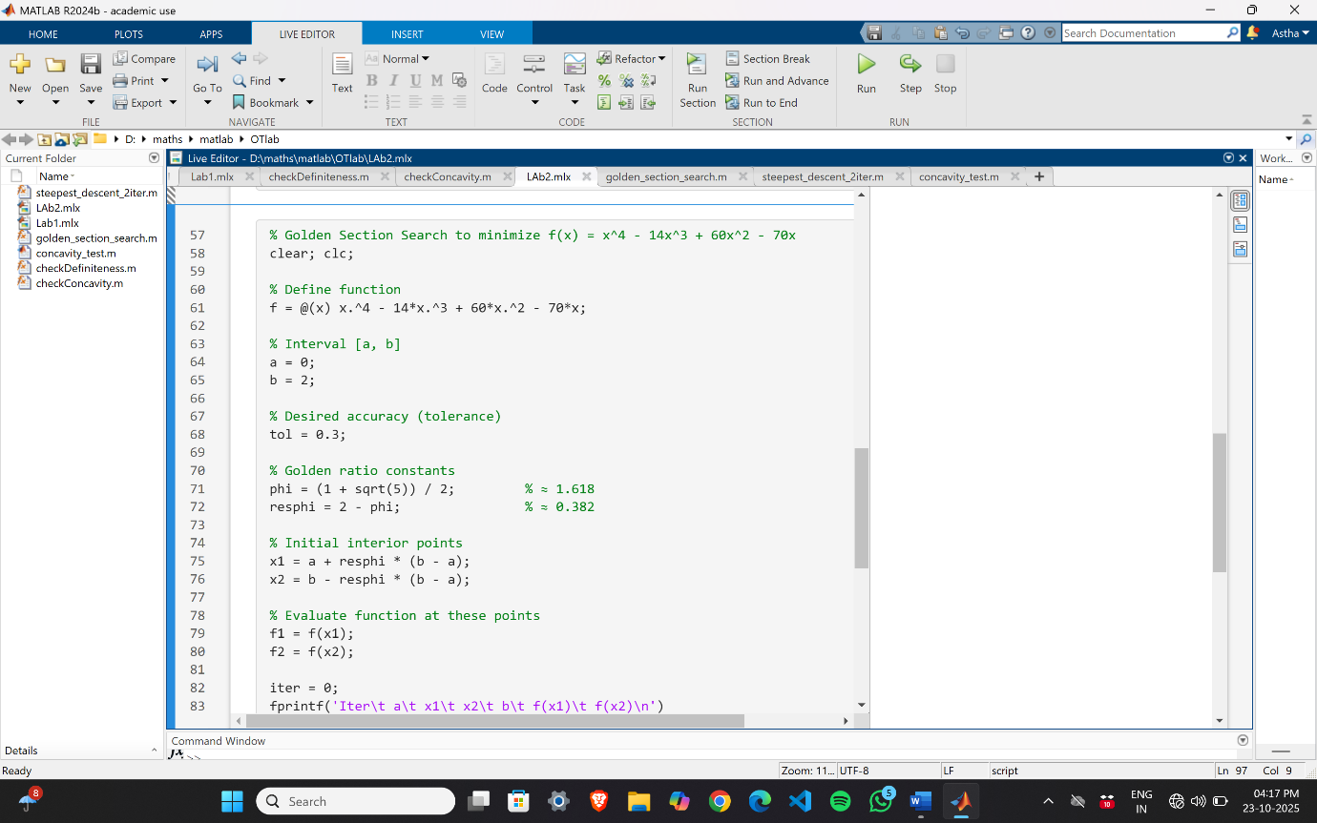

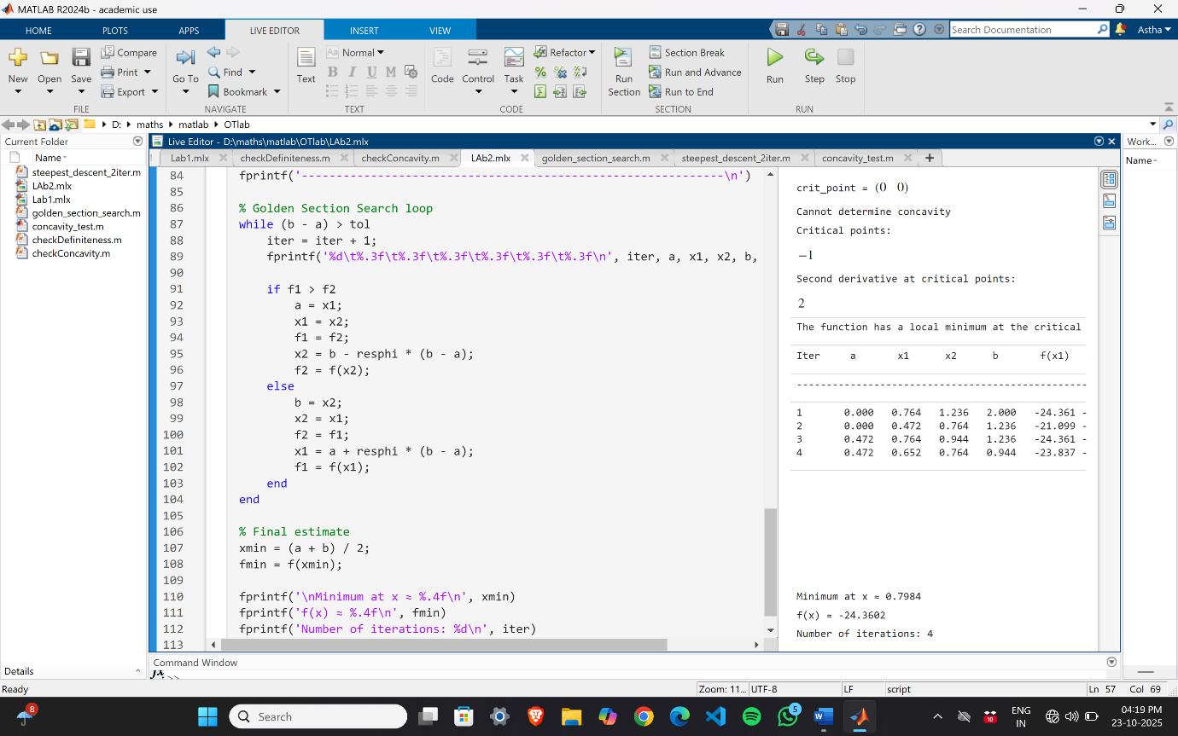

1. **Perform two iterations leading to the minimization of f(x1,x2)=x1+(1/2)x2+(1/2)x12+x22+3 using the steepest descent method with the starting point x(0)= 0. Also determine an optimal solution analytically**.

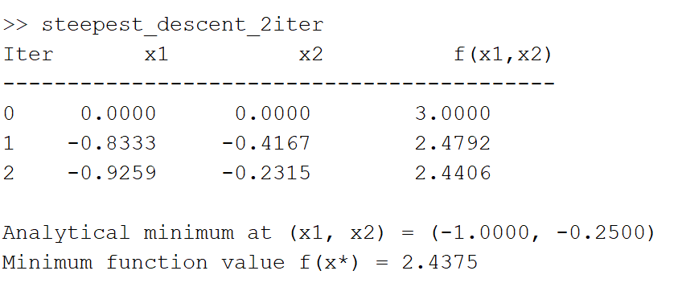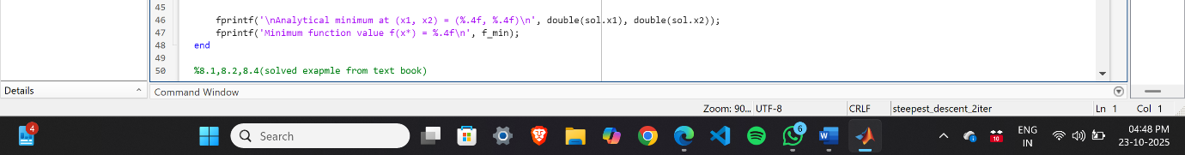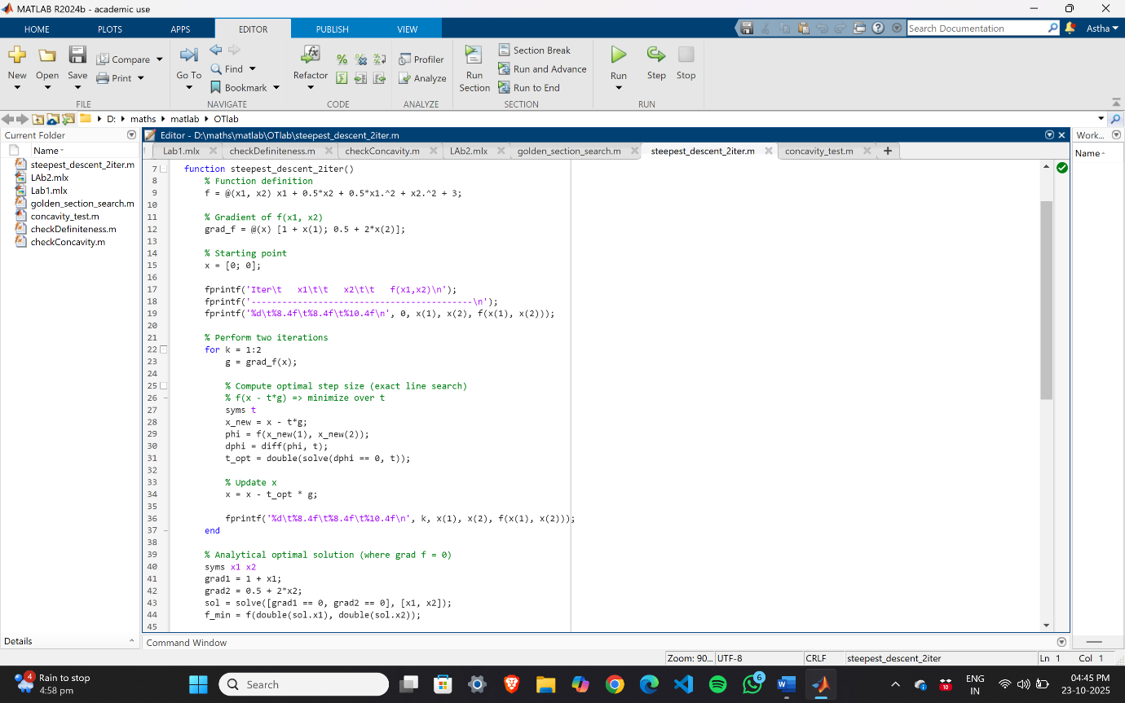

1. **Use the method of steepest descent to find the minimizer of**

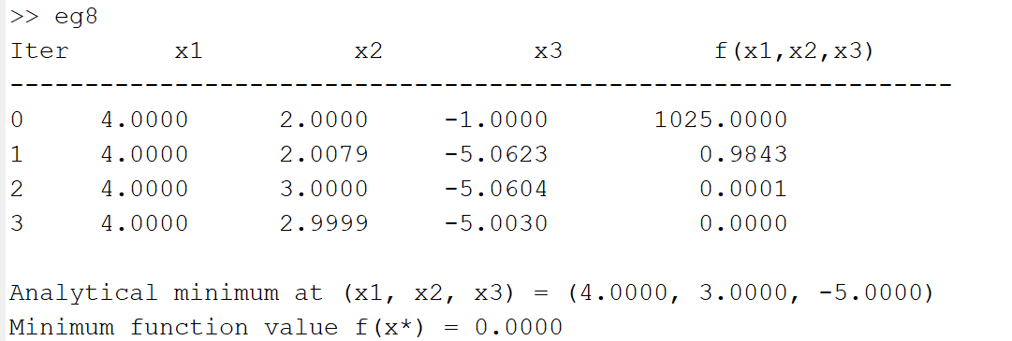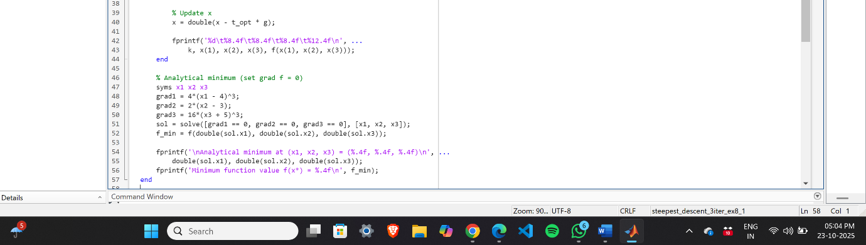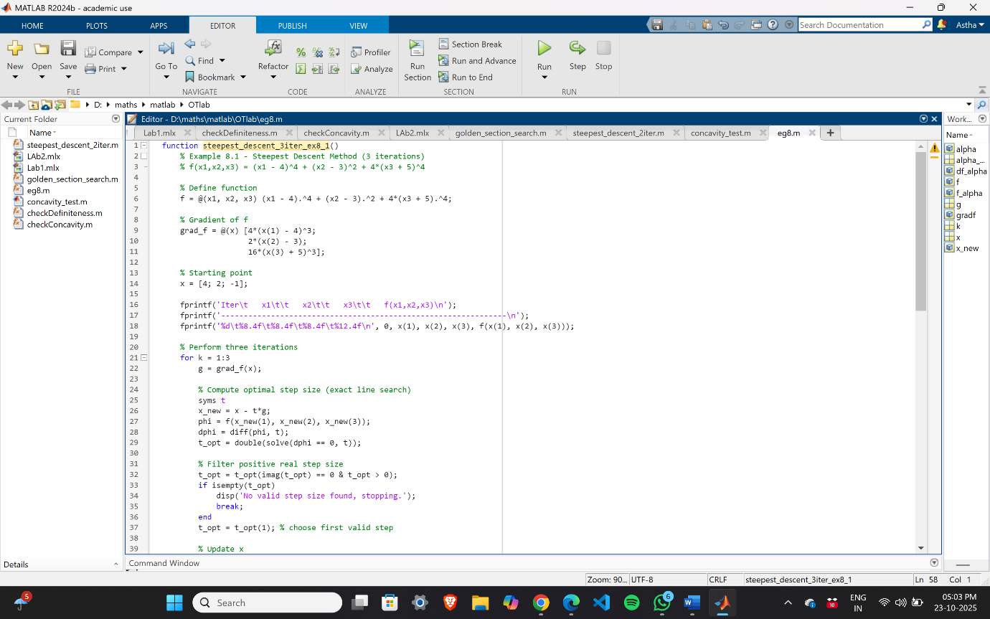

1. 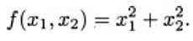**Let Then, starting from an arbitrary initial point x(0) .**

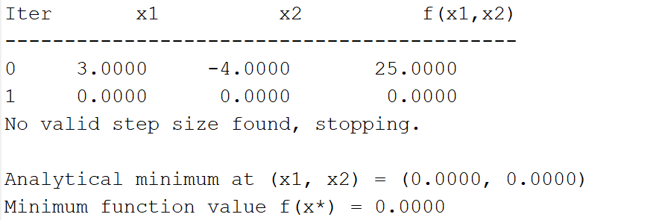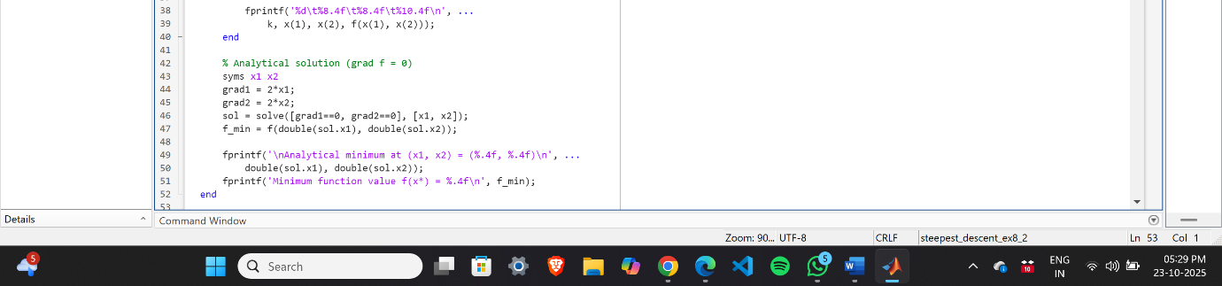

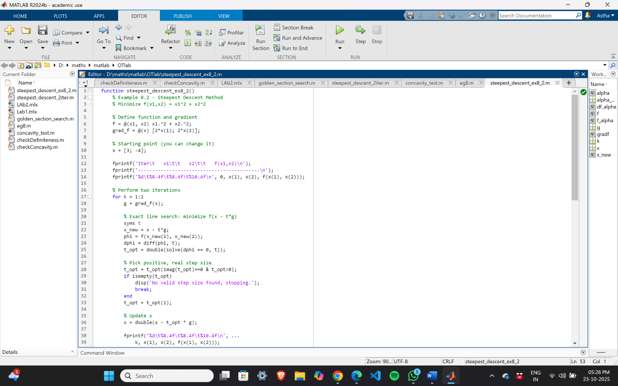

1. 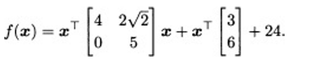**Let the function f be given by**

**Find the minimizer of f using a fixed-step-size gradient algorithm where α is a fixed step size.**

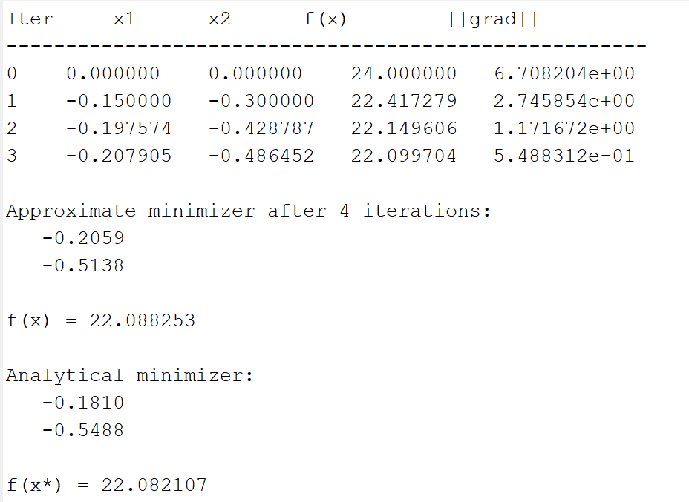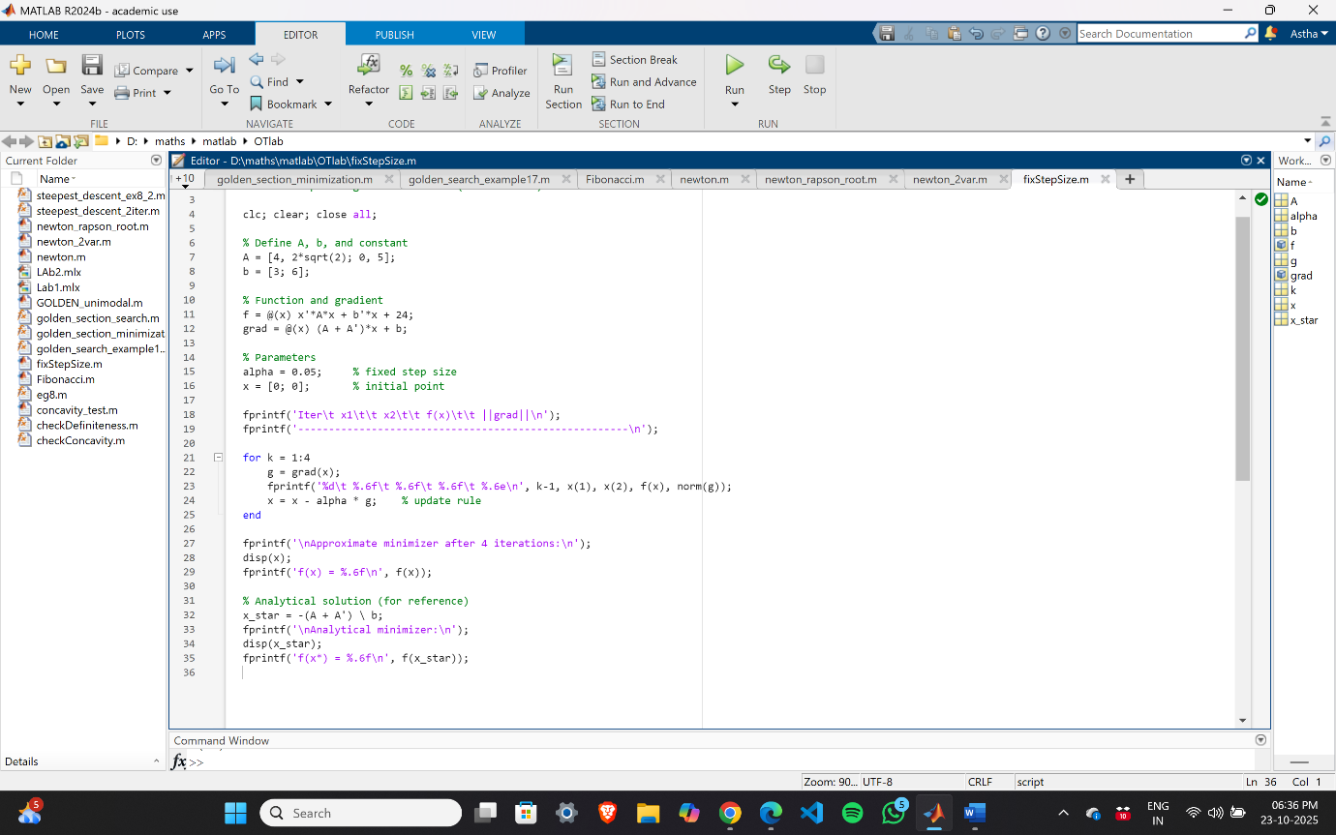

1. **Suppose that we have a unimodal function over the interval [5, 8]. Give an example of a desired final uncertainty range where the golden section method requires at least four iterations, whereas the Fibonacci method requires only three. You may choose an arbitrarily small value of ε for the Fibonacci method.**

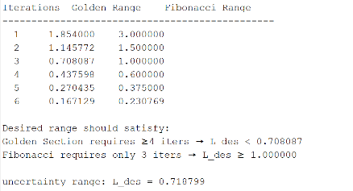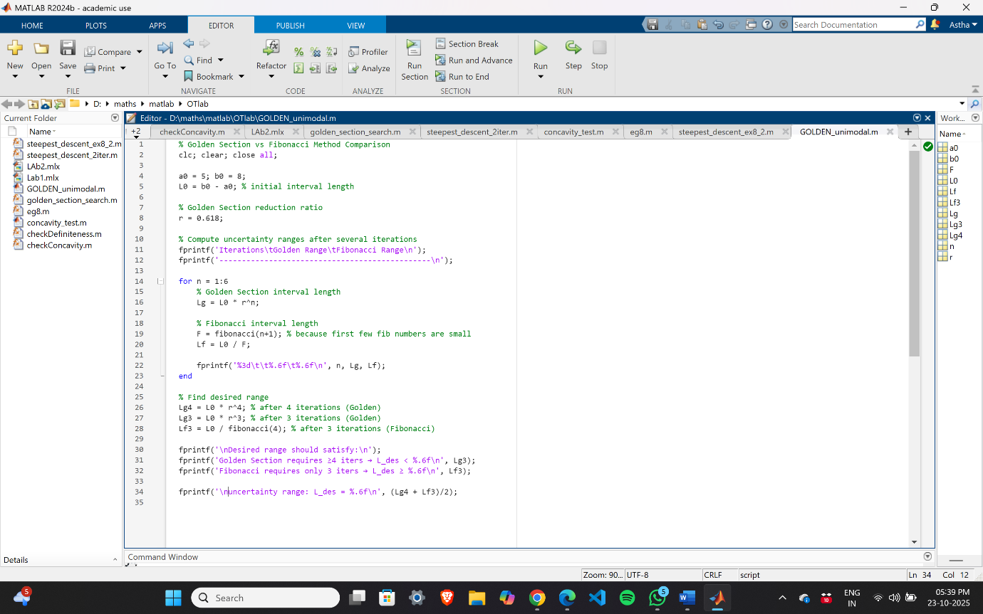

1. 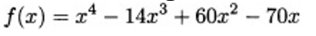**Use the golden section search method to find the value of x that minimizes in the interval [0,2] of x within a range of 0.3.**

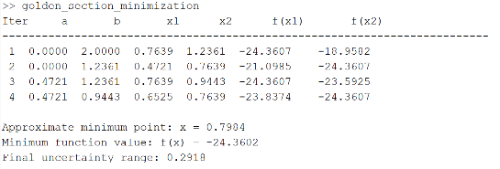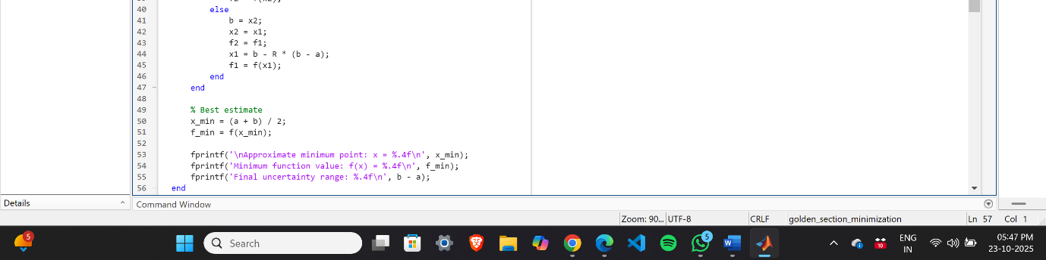

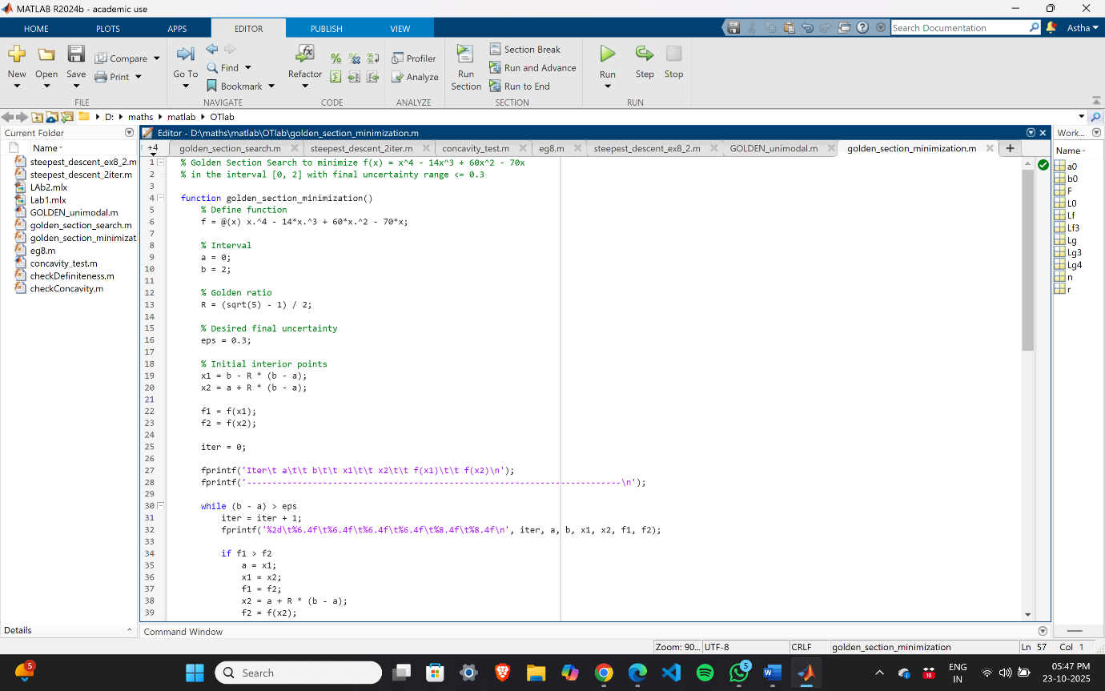

1. **Use the golden section search method to find the value of x that minimizes in the interval [1,2] of x within a range of 0.23.**

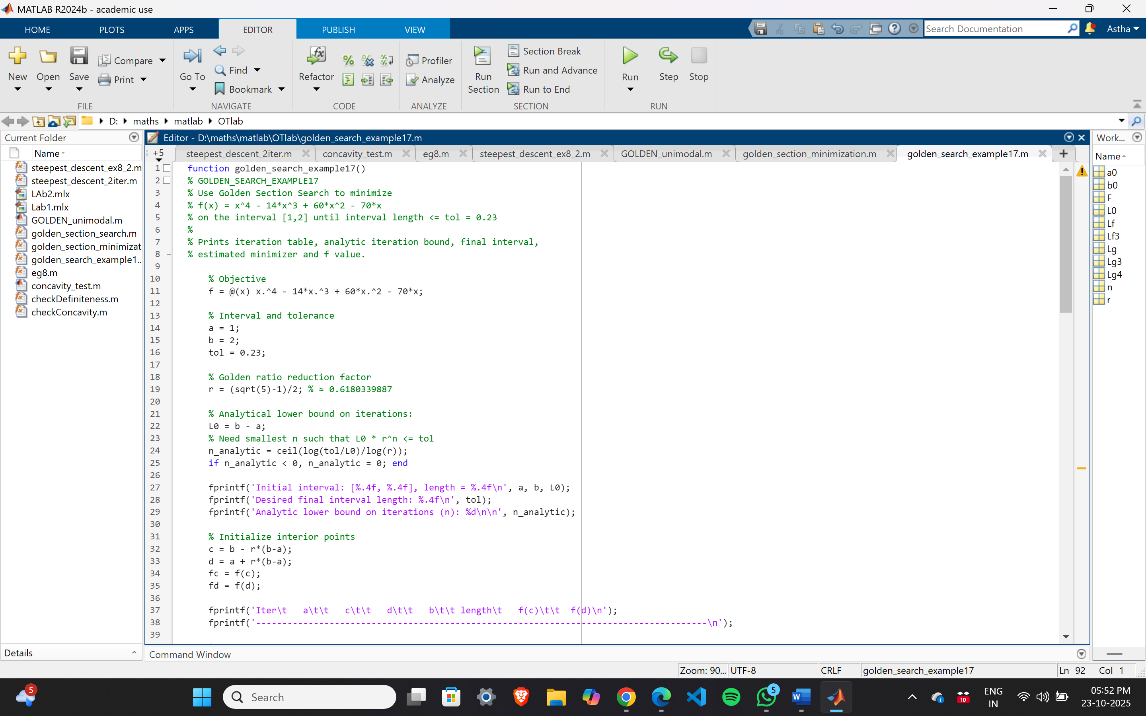

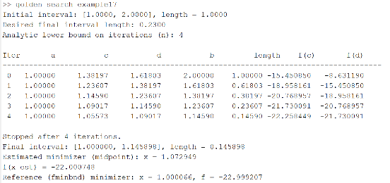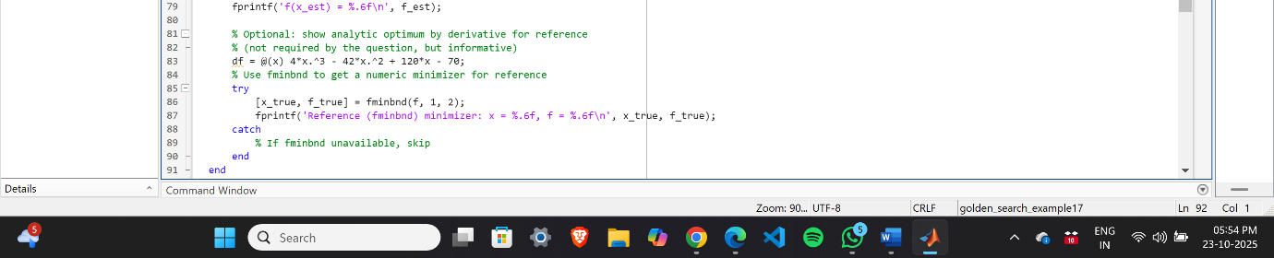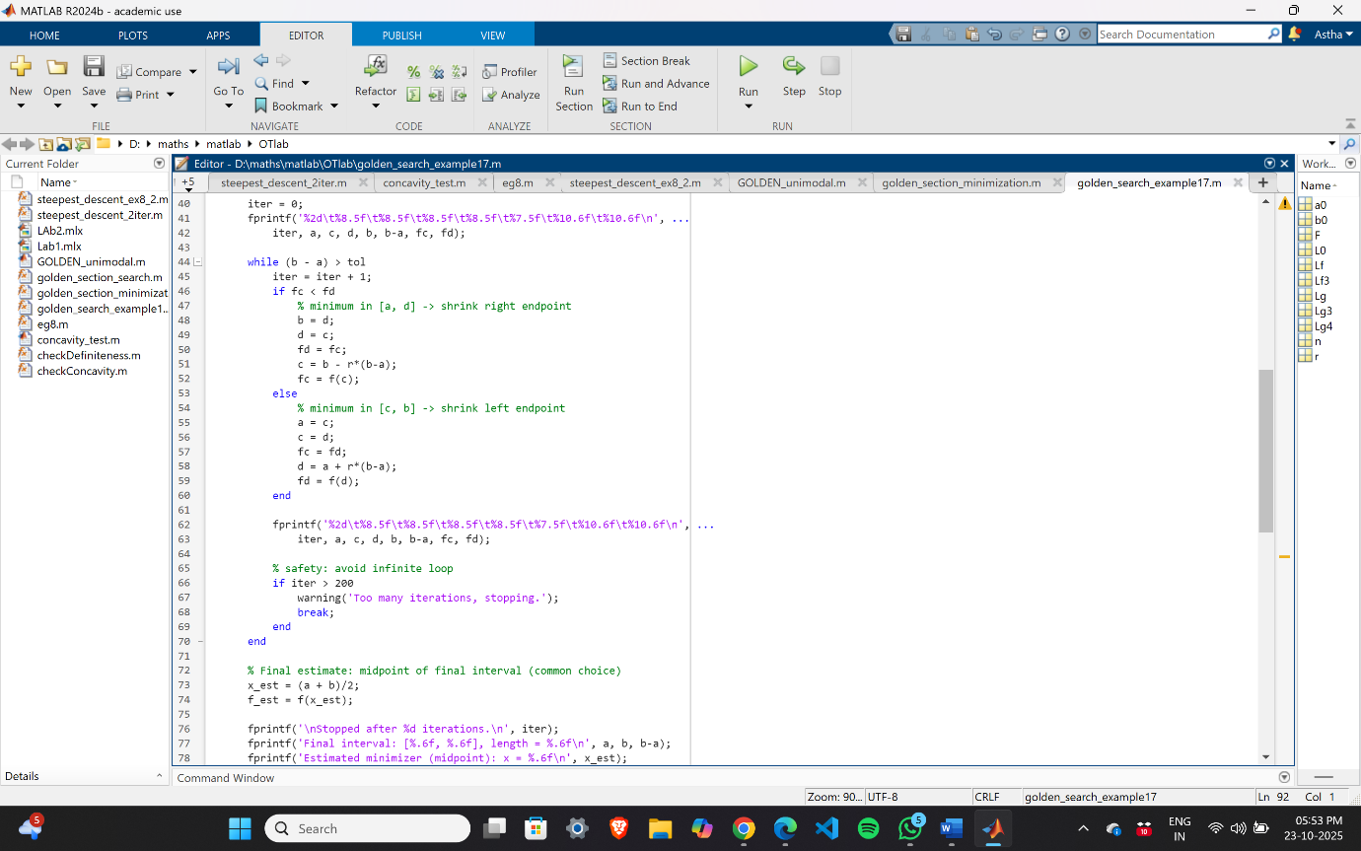

1. **Use the Fibonacci method to find the value of x that minimizes in the interval [1,2] of x within a range of 0.23.**

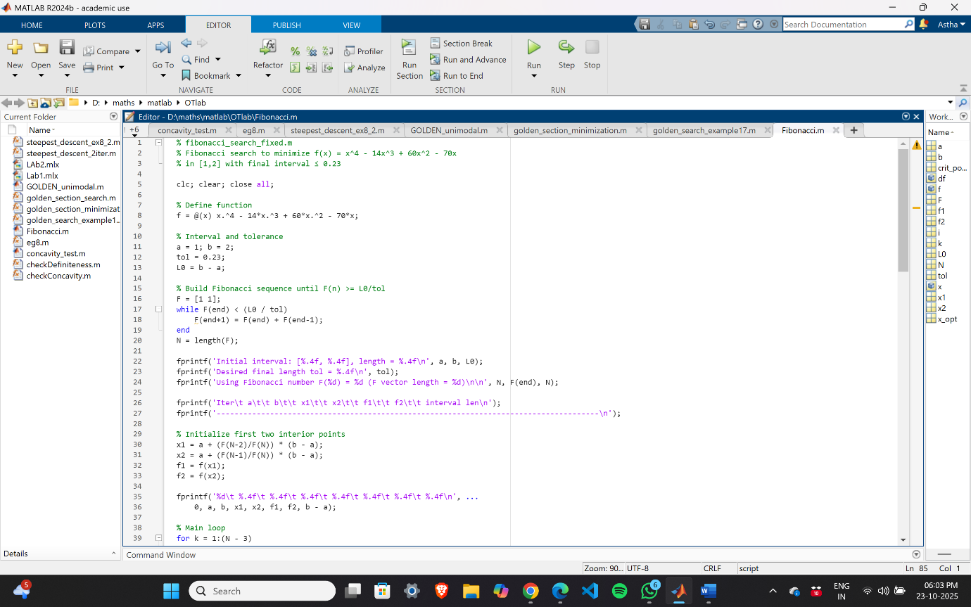

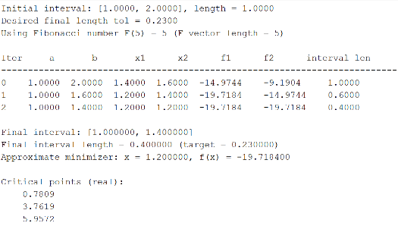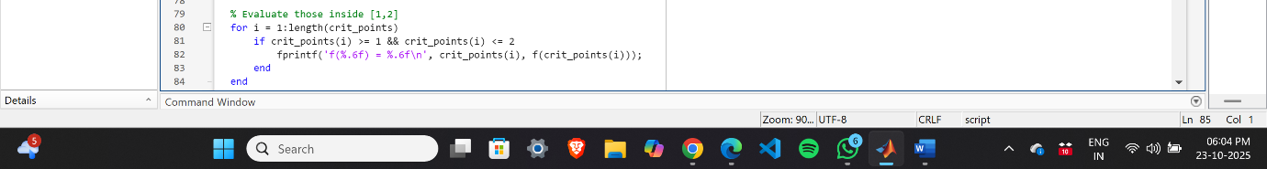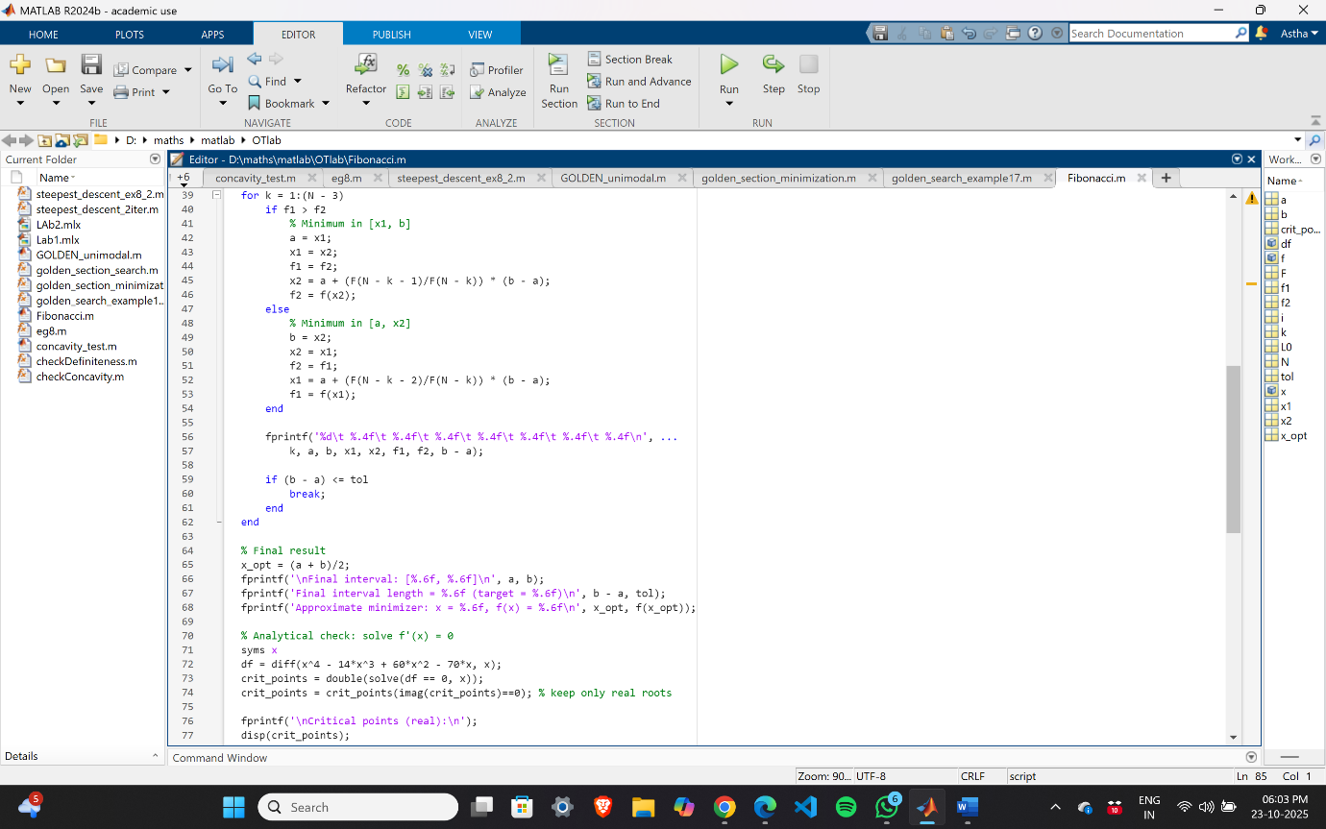

1. **Write a matlab code to find minimizer of a given function using Newton’s Method.**

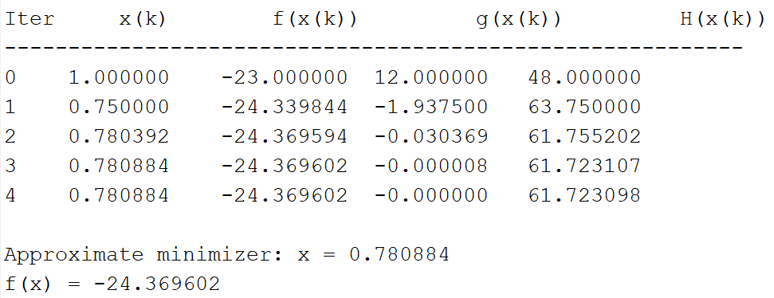

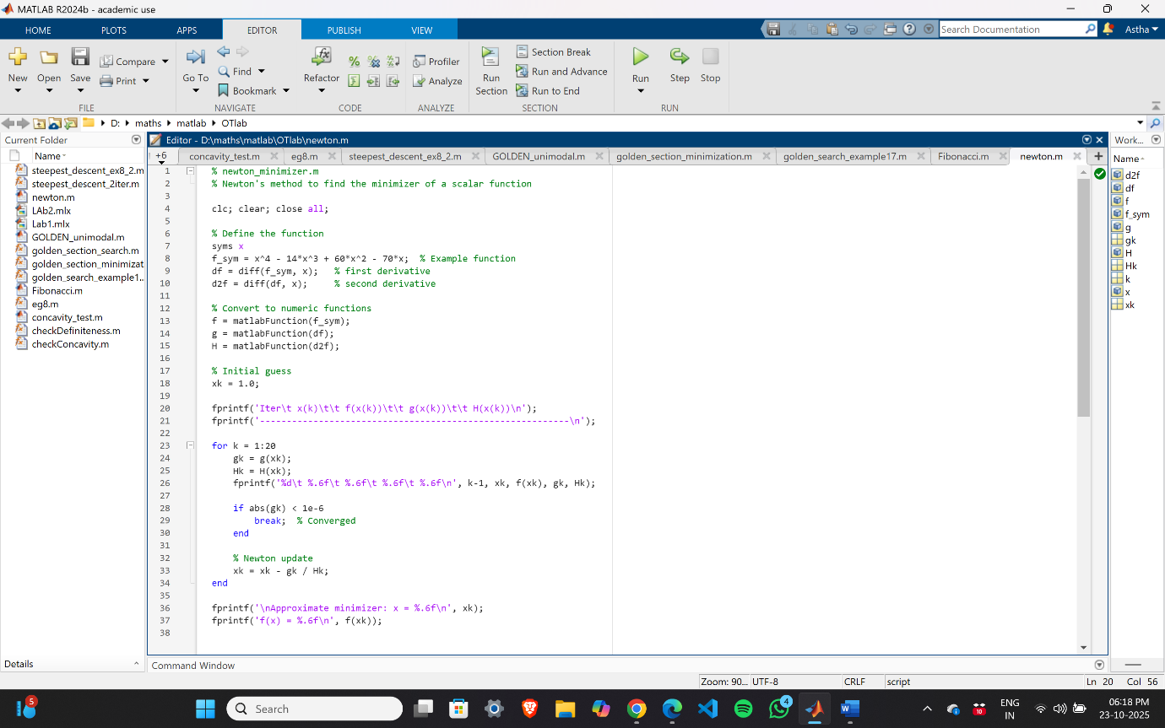

1. 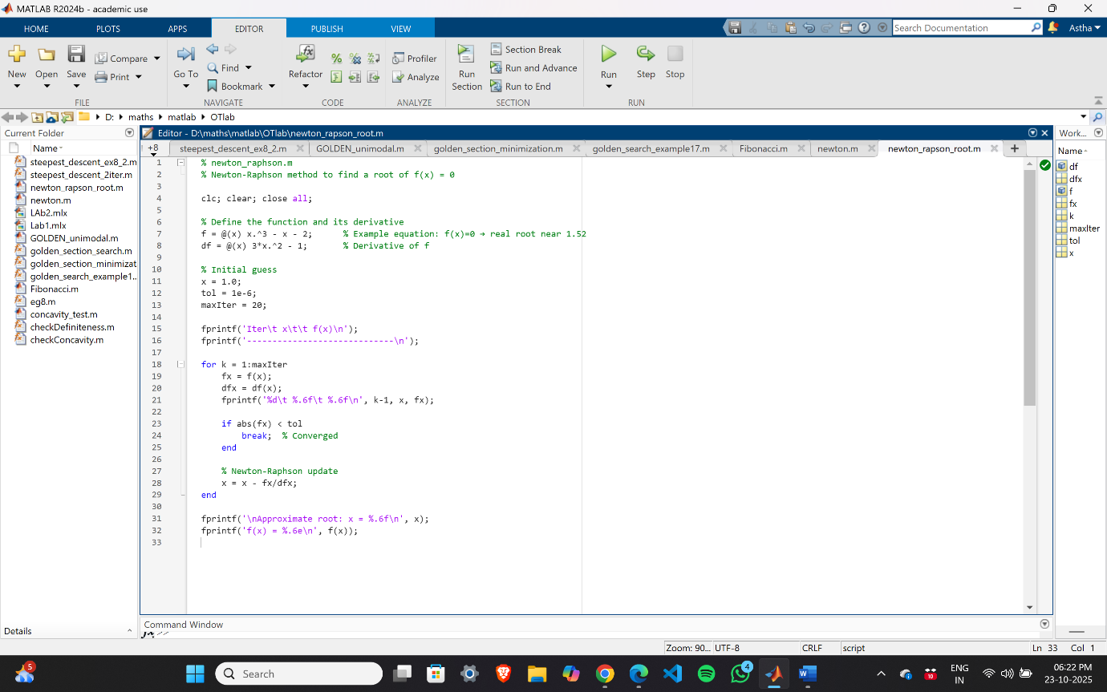**Write a matlab code to find root of a given function using Newton’s Rapson Method.**

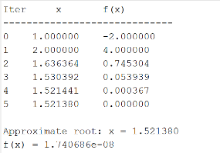

1. **Write a matlab code to find minimizer of a given function using Newton’s Method for 2 variable.**

